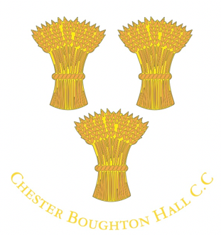
CBH Membership 2019
How to pay your membership fee, when it’s due, and what it costs.
In 2019 we’re switching to online payments via our CBHCC Pitchero website. Card payments are secure and can be made simply and efficiently.
This method ensures the minimum administrative work for us and enables the Club to keep its records up to date.
By keeping our database clean and accurate, we can communicate more easily with members, and captains can manage team selection online.
We know they’ll be one or two teething issues but we hope that ultimately we can collect all fees in this way. For now though we’ll still offer BACS and cheque payment methods while we ‘bed in’. Details at the end of this note.
Please address any queries to cbhcc@btinternet.com or call/text Jim Law on 07900 975826.
___________________________________________________________
All fees must be paid by Wednesday 1st May.
Players not paying in full by this date will be unavailable for selection until they’ve paid. There’s no deadline for social members but early payment is appreciated.
Thank you in advance to all players and social members for paying on time – membership fees are one of the key financial contributors to keeping the club running and in good nick.
How to pay your 2019 membership fee
- You need to be a member of our website: www.chesterboughtonhall.co.uk
- If not already registered, it’s simple. Go to the home page and click on the green button in the top right hand corner ‘Join this club’ and complete your details
- Once registered/logged in, click on the ‘Payments’ button on the bar at the top
- Now click on the appropriate membership category (all are listed below)
- From here follow the purchase procedures completing the membership form.
2019 membership fees
- Senior men playing £125 (before 1 May 2019) / £135 after 1 May 2019
- Over 40s (Blazers) £55*
- Senior women playing £70
- Vice-presidents – Donation (suggested, £50)
- Social members - £30

*If playing over 40s and in another senior side, you pay the highest of the two categories, but not both fees. If only paying over 40s cricket you only pay £55.
Junior

- School years 1-2 £5 (additional £5 cost per session)
- School years 3-6 £75
- School years 7-9 £85
- University** £70
**University students not intending playing until term ends can pay on return from university. If playing during term time, the deadline applies.
Associate membership
- May be available on an exceptional basis to part-time occasional players not playing all games due to selection or availability. The cut off point for eligibility is playing half the games in a season – ie playing (or expecting to play) in more than half of the games. In this case you should pay full fees. Please discuss with your captain.
Match fees
These are in addition to membership fees:
- Senior matches: £5 per player (£3 for 20 over matches)
- Junior matches: £2 per player.
£5 tea money is also payable by all players (eg Saturday senior players pay £5 levy + £5 tea money = £10.)
If you have difficulty paying your membership fee please speak to a club official to agree a suitable solution. The purpose of membership fees is to support the club financially, not to exclude potential members who want to play cricket.

If you can’t pay online there are two further ways of paying for your 2019 membership fees:
Online transfer (BACS):
CBHCC account details: sort code 60 40 08, account number 33100942
In the payment reference field please use the following format: SubsSurnameForename. For example, SubsBloggsJoe.
By cheque:
Please make them payable to ‘Boughton Hall Cricket Club’, and send them to: Jim Law, Pavilion View, 24 Boughton Hall Avenue, Chester, CH3 5EJ
Note:
Cash isn’t accepted with the exception of the membership fee for junior school years 1 and 2, and ad hoc social membership payments left behind the bar.

