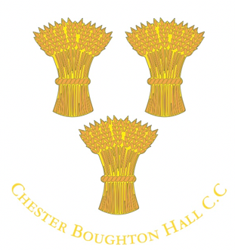
Membership 2018
How to pay your membership fee, when it’s due, and what it costs.
Membership fees stay the same this year for the fourth season in a row.
All fees must be paid by Tuesday 1st May.
Players not paying in full by this date will be unavailable for selection until they’ve paid. There’s no deadline for social members but early payment is appreciated.
Thank you in advance to all players and social members for paying on time – membership fees are one of the key financial contributors to keeping the club running and in good nick.
How to pay your 2018 membership fee
Online transfer (BACS) is our preferred way and the simplest, avoiding significant administration effort. And it’s more secure.
CBHCC account details
Sort code: 60 40 08 Account number: 33100942
In the payment reference field please use the following format: SubsSurnameForename. For example, SubsBloggsJoe.
If you don’t bank online we can accept cheques. Please make them payable to ‘Boughton Hall Cricket Club’, and send them to: Phil Evans, Chester Boughton Hall Cricket Club, Filkins Lane, Chester, CH3 5EJ
Cash isn’t accepted with the exception of the membership fee for junior school years 1 and 2, and ad hoc social membership payments left behind the bar.
2018 membership fees
- Senior men £120
- Over 40s (Blazers) £50*
- Women £65 Playing
- Girls £35 (£40 on the ECB All Star Programme)
- Associate members** £60 (Men) £35 (Women)
- Vice-presidents – Donation
- Social members - £20

Junior

- School years 1-2 £10
- School years 3-6 £70
- School years 7-13 £80
- University*** £50
*If playing over 40s and in another senior side, you pay the highest of the two categories, but not both fees. If only paying over 40s cricket you only pay £50.
**Associate membership is available on an exceptional basis to part-time occasional players not playing all games due to selection or availability. The cut off point for eligibility is playing half the games in a season – ie playing (or expecting to play) in more than half of the games. In this case you should pay full fees.
***University students not intending playing until term ends can pay on return from university. If playing during term time, the deadline applies.
Match fees
These are in addition to membership fees:
- Senior matches: £5 per player (£3 for 20 over matches)
- Junior matches: £2 per player.
£5 tea money is also payable by all players (eg Saturday senior players pay £5 levy + £5 tea money = £10.)
If you have difficulty paying your membership fee please speak to a club official to agree a suitable solution. The purpose of membership fees is to support the club financially, not to exclude potential members who want to play cricket.

